**Functional Test Report for**

**Java21 Component Release Platform 1.2.1.0-B1 Phase 3**

**11-03-2025**

# 

Testing Scope 3

Test Approach 3

Verified configuration 4

Test execution statistics 5

Functional test results by modules 5

UI Test rig for Resident 6

Detailed Test metrics 6

Sonar Report 7

# 

# Testing Scope

The scope of testing is to verify fitment to the specification from the perspective of

* Functionality
* Deployability
* Configurability
* Customizability

Verification is performed not only from the end user perspective but also from the System Integrator (SI) point of view. Hence Configurability and Extensibility of the software is also assessed. This ensures readiness of software for use in multiple countries. Since MOSIP is an “API First” product platform, Verification scope required comprehensive automation testing for all the MOSIP APIs. An automation Test Rig is created for the same.

The Resident Revamp testing scope revolves around the following flows:

* IDA
* ID Repo
* Resident
* Pre-registration Booking
* Verify phone/email
* View My history
* Track services
* Manage My VID
* Secure MY ID
* Get personalized Card
* Share credentials with partner

# Test Approach

Persona based approach has been adopted to perform the IV&V, by simulating test scenarios that resemble a real-time implementation.

A Persona is a fictional character/user profile created to represent a user type that might use a product/or a service in a similar way. Persona based testing is a software testing technique that puts software testers in the customer's shoes, assesses their needs from the software and thereby determines use cases/scenarios that the customers will execute. The persona needs may be addressed through any of the following.

* Functionality
* Deployability
* Configurability
* Customizability

The verification methods may differ based on how the need was addressed.

For regression check, “MOSIP Test Rig” - an automation testing suite - which is indigenously designed and developed for supporting persona-based testing. MOSIP Test Rig covers the end to end test execution and reporting. The end to end functional test scenarios are written starting from pre-registration, to creation of packet in registration center, processing the packet through the registration processor, generating UIN and authenticating identity using IDA through various permutation and combinations of cases being covered. MOSIP Test Rig will be an open source artifact which can also be enhanced and used by countries to validate the SI deliveries before going live. Persona classes include both negative and positive personas. Negative persona classes include users like Bribed Registration Office, Malicious Insider etc. The needs of positive persona classes must be met, whereas the needs of negative persona classes must be effectively restricted by the software.

# Verified configuration

Verification is performed on various configurations as mentioned below

* Default configuration - with 3 Lang (English/Arabic/French)

# Test execution statistics

## Functional test results by modules

Below are the test metrics for IDA, ID Repo and Resident service UI and API..

API Test Rigs :

| **Total** | **Passed** | **Failed** | **Skipped** | **Ignored** |
| --- | --- | --- | --- | --- |
| 2046 | 1943 | 15 | 0 | 88 |
| Test Rate: 95% With Pass Rate : 99% | | | | |

Here is the detailed breakdown of metrics for each module:

|  | | **Test cases** |
| --- | --- | --- |
| IDA | Total | 512 |
| Passed | 496 |
| Failed | 12 |
| Skipped | 0 |
| Ignored | 4 |
| ID Repo | Total | 410 |
| Passed | 325 |
| Failed | 1 |
| Skipped | 0 |
| Ignored | 84 |
| Resident | Total | 1124 |
| Passed | 1122 |
| Failed | 2 |
| Skipped | 0 |

In IDA the Ignored 4 test cases are related to Generating VID using ID Repo API. So, this feature is not supported/needed. Currently to generate VID we are using Resident API.

In ID Repo we have 84 test cases in Ignored, they are all for “array of handles” test cases and Add identity test cases, for now we are ignoring them.

## UI Test rig for Resident

| **Total** | **Passed** | **Failed** | **Skipped** |
| --- | --- | --- | --- |
| 25 | 24 | 1 | 0 |
| Test Rate: 100% With Pass Rate: 99% | | | |

Functional and test rig code base branch which is used for the above metrics is:

Hash Tag:

*******************

sha256:fa7ec4181c78018e5ac8cdf148f59c905bb2973a6052c10673d8302aa9912d75

## Detailed Test metrics

Below are the detailed test metrics by performing manual/automation testing. The project metrics are derived from Defect density, Test coverage, Test execution coverage, test tracking and efficiency.

The various metrics that assist in test tracking and efficiency are as follows:

* Passed Test Cases Coverage: It measures the percentage of passed test cases. (Number of passed tests / Total number of tests executed) x 100
* Failed Test Case Coverage: It measures the percentage of all the failed test cases. (Number of failed tests / Total number of test cases executed) x 100

Github link for the xls file:

<TBD>

## Sonar Report

ID- Authentication

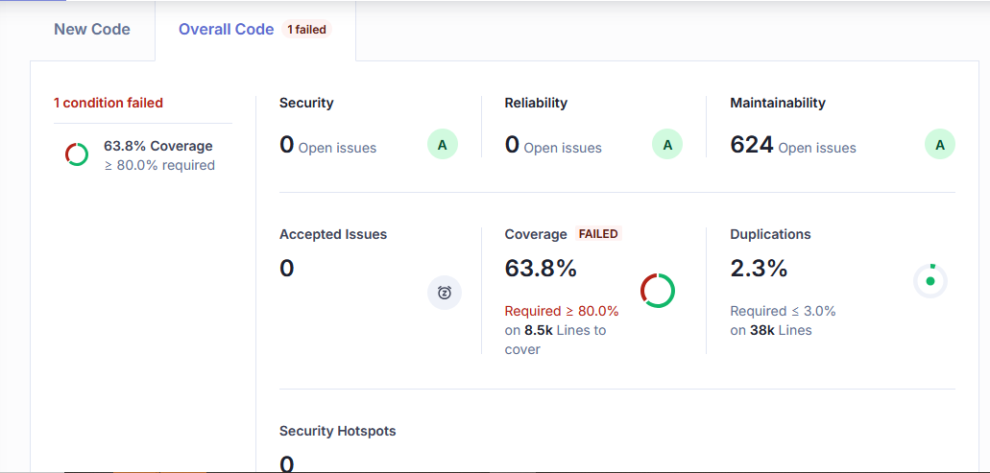

ID-Repo

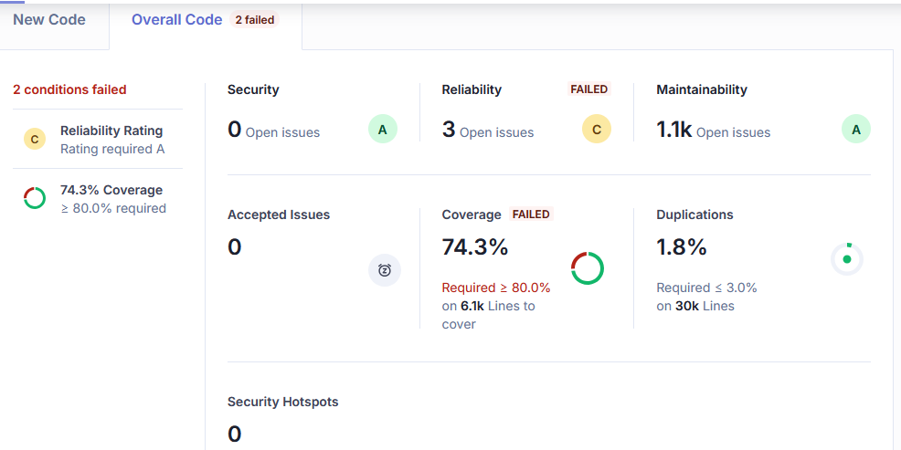

Resident

